HTML Web Projects Output
Q1: Camperbot's Profile Page
Hello from Camperbot!
About
My name is Camperbot and I love learning new things.
Background and Interests
I enjoy solving puzzles.

Q2: Pet Adoption Page
Welcome To TANVI Pet Adoption!
Consider adopting a pet today. We have cats, dogs, rabbits and more
See our cats!

Figure 1: Two tabby kittens sleeping together on a couch.
Adopt a cat!
Visit cats page
Adopt a dog!
Visit dogs page

Q3: Chocolate Chip Cookies Recipe
Chocolate Chip Cookies Recipe
Welcome to the ultimate guide for making mini chocolate chip cookies!
These bite-sized treats are perfect for satisfying your sweet tooth without overindulging.
Follow this simple recipe to create delicious, crispy-on-the-outside, chewy-on-the-inside mini chocolate chip cookies that everyone will love.
Ingredients
1 cup all-purpose flour
1/2 teaspoon baking soda
1/2 cup unsalted butter, softened
1/2 cup granulated sugar
1/2 teaspoon vanilla extract
1/2 cup mini chocolate chips
Instructions
- Preheat the oven to 375°F (190°C) and line a baking sheet with parchment paper.
- In a bowl, whisk together the flour and baking soda.
- In another bowl, beat the butter, sugar, and vanilla extract until creamy.
- Gradually add the dry ingredients to the wet mixture, then fold in the mini chocolate chips.
- Drop small spoonfuls of dough onto the prepared baking sheet.
- Bake for 8-10 minutes or until the edges are golden brown.
- Let the cookies cool on the baking sheet for a few minutes before transferring them to a wire rack to cool completely.
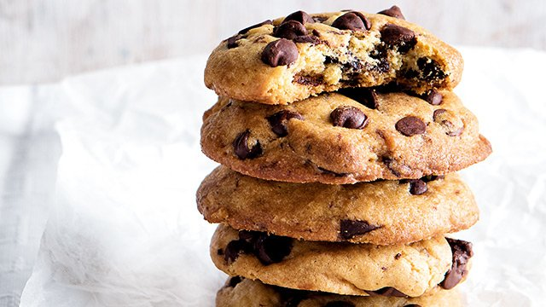
Figure 2: Tasty chocolate chip cookies

Q4: Bookstore Page
Tanvi Bookstore
Browse our collection of amazing books!
Sally's SciFi Adventure
This is an epic story of Sally and her dog Rex as they navigate through other worlds.
[Buy Now]
Dave's Cooking Adventure
This is the story of Dave as he learns to cook everything from pancakes to pasta, one recipe at a time.
[Buy Now]

Review your selections and continue to checkout.
[View Cart] [Checkout]

Q5: Travel Agency Page
Discover Italy
Art, folklore, food, nature and more. Choose among our wide selection of guided tours and excursions, and live an unforgettable experience exploring Italy.
Packages
We offer an extensive range of holiday solutions to accommodate the needs of all our clients. From daily excursions in the most beautiful cities, to thorough tours of hidden villages and medieval towns to discover Italy's lesser-known sides.
(https://www.kesari.in/)
(https://www.getyourguide.com/)
Top Itineraries
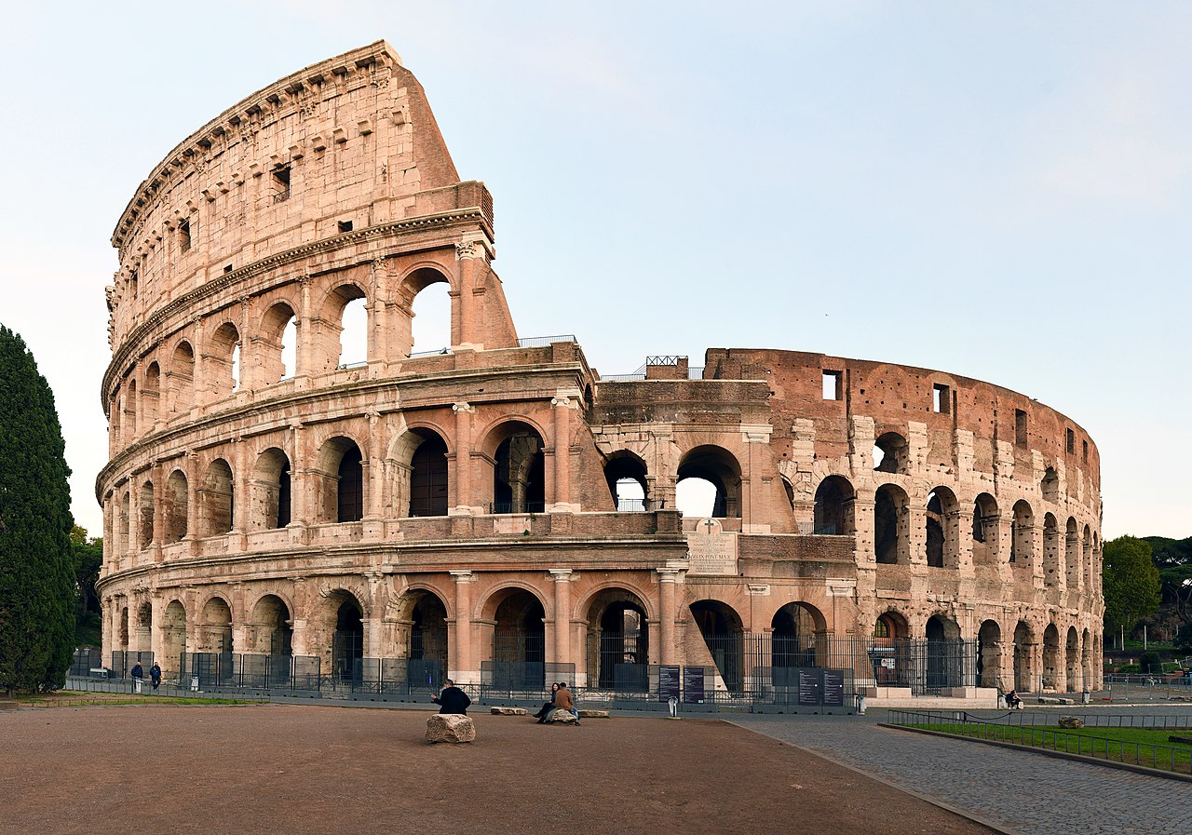
Figure 3: Roman Colosseum
Rome and Center Italy

Figure 4: National Park in Italy
Italy's National Parks

Figure 5: Southern Italy Coastline
South Italy and Islands

Q6: Student Feedback Survey Form
Student Feedback Survey
Please fill out this survey form to help us improve our learning experience.
Name: ________________
Enter your full name
Email: ________________
Enter your email address
Age: ________________
Enter your age
Current Role: Student
Would you recommend this course?
- ☐ Yes
- ☐ No
What did you like? (Select all that apply)
- ☐ Course Content
- ☐ Teaching Method
- ☐ Lab Sessions
Additional Comments:
Comments: _________________________________
[Submit]

Q7: Personal Portfolio
My Personal Portfolio
About Me
Hello! I am Tanvi Patil. I am a Second Year AIML Engineering student at St. Francis Institute of Technology. I am interested in Artificial Intelligence, Web Development, and Machine Learning.
Education
Qualification | Institution | Year
ICSE | St. Francis School | 2022
HSC | Mt. Carmel's Junior College | 2022-2024
B.E. AIML | St. Francis Institute of Technology | 2024-2028

Table 1: Educational Qualifications
Skills
HTML & CSS
Python Programming
Basic JavaScript
Problem Solving
Contact Me
Name: ________________
Email: ________________
Message:

[Submit]

